Quantitation of Energy Exchange

1. *Measuring the Heat Exchange*

A. Specific Heat Capacity

When a system absorbs heat, its temperature increases.

The increase in temperature is directly proportional to the amount of heat absorbed.

It depends on the type of material being heated.

A substance with a high specific heat can absorb a lot of heat without changing temperature

The specific heat capacity is the amount of heat energy required to raise the temperature of one gram of a substance 1 °C. Unit: J/g



B. Quantifying Heat Energy Absorbed or Released

The heat capacity of an object is proportional to the following:

m = mass

c = specific heat of the material

∆T = final temperature of system – initial temperature of system

**q = mc∆T**

Specific Heat Capacity-Measure of a substance’s intrinsic ability to absorb heat.

The specific heat capacity is the amount of heat energy required to raise the

temperature of one gram of a substance 1 °C. Units: J/g◦C

The molar heat capacity is the amount of heat energy required to raise the

temperature of one mole of a   
substance 1 °C. Unit J/mole◦C

2. *Heat Exchange and Thermal Equilibrium*

When two objects at different temperatures are placed in contact, heat flows from the material at the higher temperature to the material at the lower temperature.

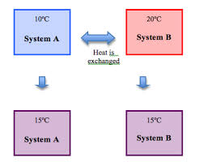

Heat flows until both materials reach the same final temperature.

The amount of heat energy lost by the hot material equals the amount of heat gained by the cold material.

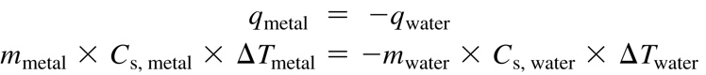

.

.

Example: A 4.75 g block of metal at 55 °C is added to 15. 23 water at 25 °C. What is the specific heat capacity of the metal? (specific heat capacity of liquid water = 4.18 J/g◦C). Thermal equilibrium occurs at 27◦C

A 100 g sample of a metal was heated to 100◦C and then quickly transferred to an insulated container holding 100g of water at 22◦C. The temperature of the water rose to a final temperature of 35◦C. Which of the following can be concluded?

a. The metal temperature changed more than the water temperature did: therefore the metal lost more thermal energy than the water gained.

b. The metal temperature changed more than the water temperature did, but the metal lost the same amount of thermal energy as the water gained.

c. The metal temperature changed more than the water temperature did, therefore the heat capacity of the metal must be greater than the heat capacity of the water.

d. The final temperature is less than the average starting temperature of the metal and the water; therefore the total energy of the metal and water decreased.

3. When a chemical reaction occurs in an *open* container most of the energy gained or lost is in the form of *heat*.

* Almost no *work* is done (i.e. nothing is being moved).
* Heat flows between the system and surroundings until the two are at the same temperature.
* Unit is Joules

2. Enthalpy

Under conditions of *constant pressure* the heat gained or lost is termed *enthalpy* (or "heat content").

3. *The change in enthalpy, ∆H, equals the heat, qp, gained or lost by the system when the process occurs under constant pressure*:

*∆H=qp*

**Enthalpy-** Unit is Joules

a. Cannot be directly measured.

b. We measure the change in enthalpy.

c. Is a state function, the pathway doesn’t matter.

d. ΔHrxn = Hproducts – H reactants

ΔHrxn = (-) reaction is **exothermic, products** are more stable due to lower energy.

ΔHrxn = (+) reaction is **endothermic, reactants** are more stable due to lower energy.

e. ∆H is an extensive property- the amount matters

f. ∆H for the reverse reaction has the same magnitude but the sign is reversed.

A. For an exothermic reaction, the surrounding’s temperature rises due to a release of thermal energy by the reaction.

B. This extra thermal energy comes from the conversion of some of the chemical potential energy in the reactants into kinetic energy in the form of heat.

C. During the course of a reaction, existing bonds are broken and new bonds are made.

D. The products of the reaction have ***less*** chemical potential energy than the reactants.

E. The difference in energy is released as heat

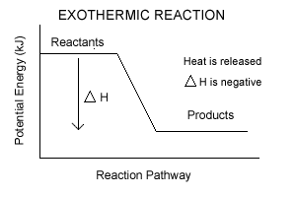

A. In an endothermic reaction, the surrounding’s temperature drops due to absorption of some of its thermal energy by the reaction.

B. During the course of a reaction, existing bonds are broken and new bonds are made.

C. The products of the reaction have ***more*** chemical potential energy than the reactants.

D. To acquire this extra energy, some of the thermal energy of the surroundings is converted into chemical potential energy stored in the products.

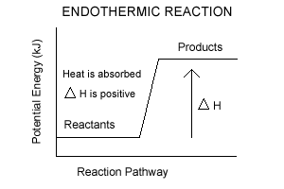

4. Calculating Enthalpy from Standard Enthalpies of Formation- ΔHºf is the change in enthalpy that accompanies the formation of one mole of a compound from its elements. All substances will be in the standard state.

a. Standard State 1 atm, 1 M, 298K. For an element, it is the state of matter for the element exists at 25C.

b. Use this formula:

**ΔHrxn = Σ ΔHf (products) - Σ ΔHf (reactants)**

c. Hints:

i. all elements have a ΔHf  = 0.

ii. if the substance is multiplied by a coefficient, multiply ΔHºf  by the same coefficient.

*Sample Problem D*: Calculate the ΔH°rxn for the following:

3 Al(s) + 3 NH4ClO4(s) → Al2O3(s) + AlCl3(s) + 3 NO(g) + 6 H2O(g)

Given the following values:

Substance ΔHf° (kJ/mol)

NH4ClO4(s) -295

Al2O3(s) -1676

AlCl3(s) -704

NO(g) 90.0

H2O(g)-242

*Answer*: -2680 kJ (exo)

**Exercise 10**

Using enthalpies of formation, calculate the standard change in enthalpy for the thermite reaction:

2A1(s)+Fe2O3(s) → A12O3(s)+2Fe(s)

This reaction occurs when a mixture of powdered aluminum and iron (III) oxide is ignited with a magnesium fuse.

**= -850. kJ**

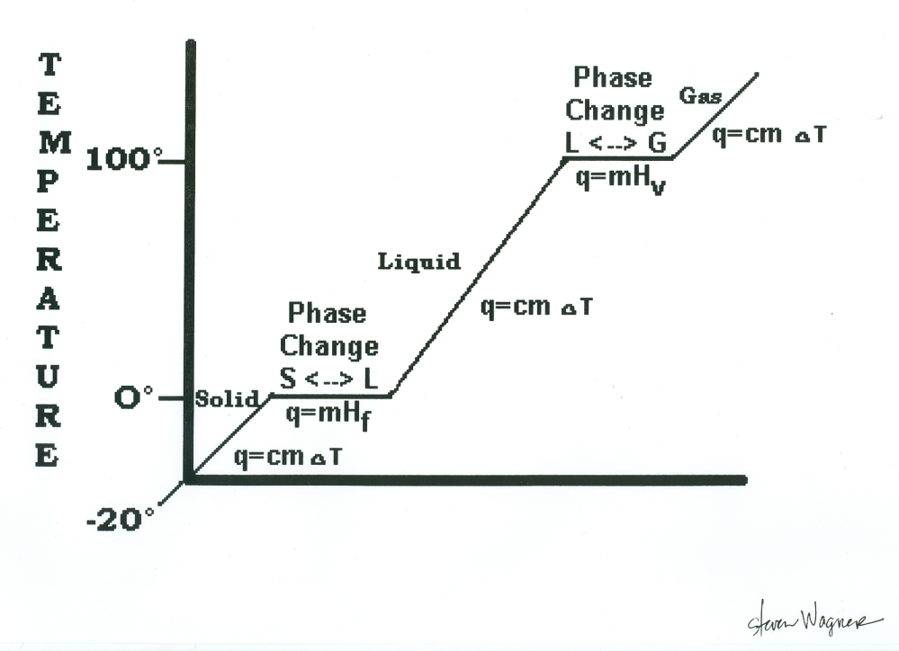

*Sample Problem E*: Sometimes all values are not found in the table of thermodynamic data. For most substances it is impossible to go into a lab and directly synthesize a compound from its free elements. The heat of formation for the substance must be found by working backwards from its heat of combustion.

Find the ΔHf of C6H12O6(s) from the following information:

C6H12O6(s) + 6 O2(g) → 6 CO2(g) + 6 H2O(l) + 2800 kJ

Substance ΔHf° (kJ/mol)

CO2(g) -393.5

H2O(l) -285.8

*Answer:* ΔHf° =-1276 kJ/mol for glucose

solid q = mc∆t c = 2.03 J/gC

melt q = mHf Hf = 334 J/g

liquid q = mc∆t c = 4.18 J/gC

boil q = mHv Hv = 2260 J/g

gas q = mc∆t c = 2.01 J/gC

Calculate the amount of heat (q) needed to warm 25grams of ice at -15C to steam at 112C.

*Sample Problem B*:

In a coffee cup calorimeter, 100.0 mL of 1.0 M NaOH and 100.0 mL of 1.0 M HCl are mixed. Both solutions were originally at 24.6°C. After the reaction, the final temperature is 31.3°C. Assuming that all solutions have a density of 1.0 g/cm3 and a specific heat capacity of 4.184 J/g°C, calculate the enthalpy change for the neutralization of HCl by NaOH. Assume that no heat is lost to the surroundings or the calorimeter.

*Answer:* -56 kJ/mol

5. Hess’s Law-In going from a set of reactants to a set of products, the change in enthalpy is the same whether the reaction takes place in one step or in a series of steps. In other words, it does not matter how you get there – the ΔH will be the same because it is a state function.

A. Steps for Success- Look to the end reaction and then…

1. Decide how to rearrange equations so reactants and products are on appropriate sides of the arrows.
2. If equations had to be reversed, reverse the sign of ΔH also.
3. If equations had be multiplied to get a correct coefficient, multiply the ΔH by this coefficient since ΔH’s are in kJ/**MOLE** (division applies similarly)

4. Check to ensure that everything cancels out to give you the exact equation you want.

Calculate the ΔH for the combustion of C to CO:

C(s) + ½ O2 (g) 🡪 CO(g)

C(s) + O2(g) 🡪 CO2(g) ΔH = -393.5 kJ

CO(g) + ½ O2(g) 🡪 CO2(g) ΔH = -283.0 kJ

Calculate the ΔH for the reaction:

2C(s) + H2(g) 🡪 C2H2(g)

C2H2(g) + 5/2O2(g) 🡪 2CO2(g) + H2O(l) ΔH = -1299.6 kJ

C(s) + O2(g) 🡪 CO2(g) ΔH = -393.5 kJ

H2(g) + 1/2O2(g) 🡪 H2O(l) ΔH = -285.8 kJ

C6H4(OH)2 (aq) + H2O2(aq) 🡪 C6H4O2(aq) + 2H2O (l)

Calculate ΔH for the above reaction given the following reactions.

C6H4(OH)2 (aq) 🡪 C6H4O2(aq) + H2(g) ΔH= 177.4 kJ

H2(g) + O2(g) 🡪 H2O2 (aq) ΔH = -191.2 kJ

H2(g) + ½ O2(g) 🡪 H2O(g) ΔH = -241.8 kJ

H2O(g) 🡪 H2O(l) ΔH = -43.8 kJ

6. Bond Energies

a. Energy is absorbed when bonds are BROKEN (endothermic).

b. Energy is released when bonds are FORMED (exothermic).

c. **ΔHrxn** = sum of the energies required to break old bonds (positive signs) plus the sum of the energies

released in the formation of new bonds (negative signs).

**ΔHrxn = bonds broken – bonds formed**

**Reactants - Products**

Sample Problem G:

Using bond energies, calculate the change in energy that accompanies the following reaction:

H2(g) + F2(g) → 2 HF(g)

Bond Type Bond Energy

H-H 432 kJ/mol

F-F 154 kJ/mol

H-F 565 kJ/mol

